Table of Contents

1 Executive Summary
  - Business profile
  - Marketing plan
  - Operation plan
  - Risk assessment
  - Financial plan

2. Business profile
2.1 A Description of the Industry
2.2 A Description of the Business Products or Services
2.3 A Description of the Location
2.4The Legal Structure.
2.5 Issues Analysis of the Business.
2.6 A Description of the Business Objectives.
2.7 Sources of Funding

3. Marketing Plan
3.1 Features and Benefits of the Products and Services
3.2Customer Profiles
3.3Competitor Analysis
3.4Competitive Advantage
3.5 Advertising and Promotional Activities
3.6Pricing Method
3.7 Selling and Distribution Method

4. Operations Plan
4.1Operating Processes
4.2Suppliers
4.3Management Team
4.4Staff
4.5Key Personnel
4.6 Record Keeping

5. Risk Assessment
5.1Industry Risk Assessment
5.2Business Structure Assessment
5.3Risk Mitigation

6. Financial Plan
6.1 Projected Ratios
6.2 Projected Cash Flow
6.3 Projected Profit And Loss
6.4 Projected Balance Sheet
6.4 Projected Balance Sheet
6.5 Spreadsheets

7. References

1. Executive Summary

1.1Business Profile
Island delight will offer great tasteful meals to the potential customers as they are able to choose from a variety of different kind of food. This ranges from African type food to the Caribbean type of food. Furthermore this part of the plan will cover the following topics like the industry the company is in, products that we provide and the legal structure.

1.2Marketing Plan
Within this section the topics that would be covered will be a description of our customers, description of our competitors and how we would promote our business and advertise. Furthermore our main means of advertising will be through mass marketing with leaflets and the use of social media which would build our brand awareness.

1.3Operations Plan
In this section we will be talking about the operation plan that we will be using such as the equipment’s needed, who will be our suppliers and how we will manage the business. Furthermore in this section we will talk more about what staff we need recruit.

1.4Risk Assessment
In this section we will be talking about the risks that might happen if we enter the industry and how we will avoid such risks. We also have to follow the risk assessment procedures in order to protect our employees from and dangers at work by training them.

1.5Financial Plan
In this section we will be talking about how the business will be financially managed by looking sections like capital, investments, balance sheets, profit and losses which has to be accurate for future plans.

2. Business Profile

2.1 A Description of the Industry

The type of business we are in is the food service industry this is because we would be buying raw materials. Also with the skills and qualities of our cook we would be delivering great delicious tasty food to our customers. The industries that relate to the hospitality industry is the catering industry the reason being is because the catering industry is to do with events like weddings, birthdays, funerals and Batchelor parties. The reason why they relate together is because catering is more to do the provision of food at an event and hospitality. On the other hand is more to do with the accommodation and entertainment aspects of an event.

2.2 A Description of the Business Products or Services
This is an online service so everything has to be ordered in then we deliver to you, the product that we will be offering is food and drinks and the services are deliveries to our customers that make orders online. Our aim is to provide the best customer service and this will be done through preparing good meals for them. AFro Caribbean restaurant will offer diverse range of products like rice and peas jerk chicken oxtail, tea, juices, lunch, and dinner, etc. Beside these products, management will also offer variety of services. Initially, firm will provide Wi-Fi services to customers.

2.3 A Description of the Location.
Location plays an important role in different types of business; therefore, management should consider an effective place. Location of business provide large amount of benefit to internal and external management of firm. Our kitchen will be located in North London Tottenham area, which will is near to shops and shopping mall that will enable us to attract people passing by.

Our business is online so we will not be located anywhere but we are planning to own a kitchen which will be located in Tottenham, therefore we can take orders online and forward them to our chef who will be preparing the meals. We then pack the meals and give them to the delivery guy to deliver it to customers.

The most important reason behind this location is that Tottenham is full of shopping centres therefore; people like to visit this place mostly on match days. In this way management of Island Delight Afro Caribbean restaurant will give us a chance to advertise in front of local. Though, initially, firm will face certain difficulties but afterwards, these difficulties and challenges will reduce. Due to the Tottenham area, management will enjoy many benefits like medium volume of sale, high profit margin, high prices, low cost, and so on (Finch, 2013, p.

2.4The Legal Structure.
This business is going to be based on partnership where by each member has to contribute on the capital which imply that it will be equal shares for the three of us. In this aspect all partners have to follow the rules and regulations of the business which means we have to legally abiding agreements for all partners.

2.5 Issues Analysis of the Business.

SWOT ANALYSIS
Strength  - Delicious food  - Healthy food  - Customer loyalty  - Affordable food  - Affordable prices | Opportunities  - Have deals for customers  - Open up our own restaurant  - Own our own kitchen in few years to come  - Move our business to different locations  - Expand our business more
Weaknesses  - Lack of our own kitchen  - Size of the business  - Lack of enough capital | Threats  - Competitors doing business  - Economic issues such as recession  - Prices from suppliers going high

In this section we will be talking about the SWOT analysis by analysing some of our strength and weaknesse.Island Delight Restaurant we plan to provide the best food to our customers will enable us to meet their need, healthy food is also good for people as it keeps you in shape. Customer loyalty is a very important factor for any business therefore we have to make sure our customers trust us mostly when it comes to personal information as they will be ordering food online. Affordable prices are another important aspect as we have to come up with reasonable prices for the customers in order not to push them away to our competitors who might have cheaper prices.

We a have a few opportunities that we plan to fulfil in future such as opening up a restaurant that will enable us to serve more customers mostly those who hate online services. We also plan to own a kitchen and move away from sharing with other people as it can create problems such as misunderstandings and stealing ideas from each other.

Some of the weaknesses we will be facing are lack of enough money (capital ) which will force us to go for other ways of getting enough by asking for loans from banks or asking friends and families for help, size of the business might also be another issue as there many businesses doing what we do so we have to try hard to be known by the public.

Threats are big issues in a business as you have to find ways on how to avoid problems that come with it for example our main competitors are Just Eat which offer online food therefore we have to use all the tactics on how to beat them. Economic issues can affect the business as people will not have money to spend on online order as they rather go to nearby shop or restaurant that will be easy for them to buy food.

2.6 A Description of the Business Objectives.
Market analysis has been considered as an important aspect, without which business plan of firm is not completed. According to market analysis, it is important to identify key competitors, loyal customers and market overlook of an industry (Hyun, 2010, pp. 251-267).

Meet customer needs
Customers are the most important people in the business because without them the business cannot run therefore we have to make sure we meet their needs by listening to their complaints, this will help us to improve on our products and services.

Expand our business
Starting as a small business we strive to expand our business to bigger size and this can only happen if we make our customers happy so they can spread a word of mouth to other people who might have no ideas about our business, therefore our aim is to expand it more through opening restaurants in different locations.

Remaining a small and unique restaurant
Most online restaurants deal in junk food buy our business is going to be selling Afro Caribbean
Food which is rear to find online, we going to make our business unique form other through providing best food possible with variety of different kinds of meals.

Achieving profit
Every business aims to make a profit therefore we have find on how we going to achieve this and it can only happen if we provide the best products and services to our customers hence good meeting customer needs. For example find out what customers are really interested in and provide it to them, this helps the business to make enough money.

2.7 Sources of Funding
We are planning to come up with our own money if it’s not enough we will ask the a bank for loan or ask friends and family for some help as that doesn’t come with interest therefore it will give us enough time to pay our debts.

Family or friends loans. If you want to keep things simple, a supportive family or friend, with money to spare, can provide a fair, willing and reliable source of loan funding. Relatives and loved ones are more likely to trust you with their money than an outsider, and they will probably demand lower interest and fewer incentives than a commercial organisation.

Bank overdrafts. For companies with fluctuating income, a bank overdraft can provide quick, flexible cash flow. This can be good for our business as we can have enough time to pay it back without being pressured by the bank as long as we do not go over our limit. Most major banks charge interest only on the amount you overdraw, and many offer tailored packages for young.

3. Marketing Plan

Market analysis has been considered as an important aspect, without which business plan of firm is not completed. According to market analysis, it is important to identify key competitors, loyal customers and market overlook of an industry (Hyun, 2010, pp. 251-267).

There are large number of competitors exist in restaurant industry of UK. Among direct and indirect competitors, McDonalds, KFC and Burger king hold around 84% of market share of food restaurants running in the country. The rest 16% of the market share is in the hands of smaller or local brands Ahenfie, Aldana and Alamut restaurant.

Range Of Secondary Market Research
The research of this business plan will be conducted by collecting data from secondary and primary resources. The secondary data will help in evaluating competitiveness of industry in which Island Delight Restaurant will run our operations, advantages of developing a business plan and how the founders of a new business will be able to bring sustainability in our business. The secondary sources of data through which data is collected includes journals, articles, business magazines and through many internet sources.

3.1 Features and Benefits of the Products and Services
These some of the features and benefits our business will handling and our aim for this is to make sure we full fill through making the both the customers and the employees happy.

 | Features | Benefits
1 | Customers | Customers are main people for the business so we need to make sure we meet their needs by providing best products and services.
2 | Prices | The prices for our food will be affordable for our customers.
3 | Employees | Employees are also important to the business so we have to make sure they feel safe and happy to work with us.
4 | Settings | We will own our kitchen and the way we going to set this out by creating a kitchen side and an office where we will be dealing with customer orders. We also have to make sure the kitchen and the office are safe and comfortable for the staff
5 | Quality food | We will be offering delicious food to our customers.
6 | Location | Our kitchen will be located in Tottenham High road near by the stadium.
7 | Customer Service | This is an important factor for the business so we have to provide the best products and services to our customer’s in order to keep them satisfied.

3.2Customer Profiles
Below is the chart of targeted customer, which will fall into following categories;

Age | Above 18
Income | Medium
Sex | Male and Females
Family | Single, Married or no children
Geographic location | City centres
Occupation | Working to middle class
Hobbies | Sport, music.
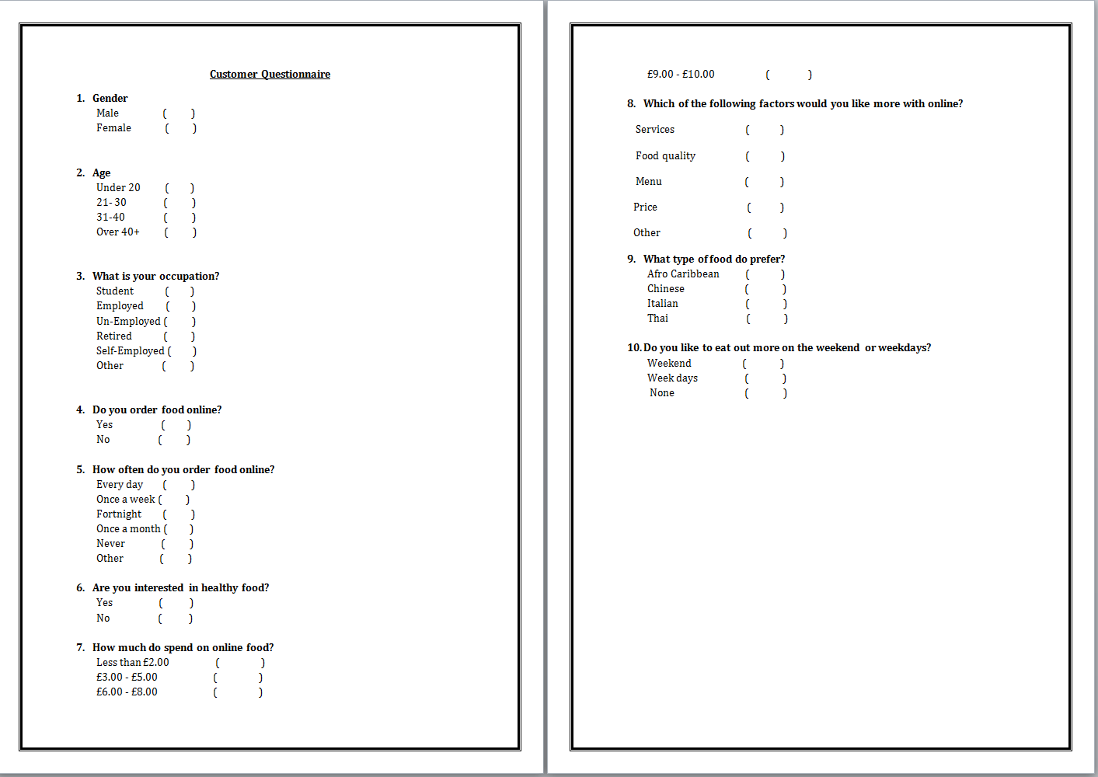
Our target is 18+ so we will have provide meals that ae affordable being that big number of them can afford it, we choose the above age because school kids in primary and secondary school might not be patient enough like adults as the food might take some minutes to be delivered.

According to our research we found out that a big number of people do not order food online as they prefer home cooked and also they have trust issues online services, but that cannot stop us from going ahead with our business plan as we had to finds ways to attract them online order by giving them offer mostly on weekdays for those working as there might not have enough time to cook due to work.

3.3Competitor Analysis
New businesses will have to compete with large number of established brands. Therefore, competitors’ analysis becomes important part of business plan. Some of the direct and indirect competitors of Island Delight Restaurant will be Ahenfie, Aldana and Alamut restaurant.

There too much competition when it comes to food industry therefore we needs to have different tactics that that enable us to win our competitors mostly those that are selling the same food, By doing this it will help us to attract more customers who would love to taste something different.

3.4Competitive Advantage
We will be different from our competitors through preparing some of the best meals and which are affordable; we plan to always consider customer complaints as customers are always right no matter how bad the situation is customer comes first.

3.5 Advertising and Promotional Activities
Leaflets
We will design leaflet with our menu included and hand them out to people on streets, students, friends and families, we will also drop them in letter boxes for different houses in different areas which will enable us to attract lot of people as they will be receiving them without stepping out of their houses.

Websites
We will design a website for the business that will help us to advertise it menus will be included on the site so customers can select what they need to be prepared for them, there will be a review section for customers to leave their comments about the products and services provided to them, therefore we have to check it every week to find out where we going wrong in order to improve.

Social media Twitter / Facebook/ Instagram
This one of the most popular promotional method used by almost everyone due to technological development, we will use this method through creating ads and send these to these sites though it might cost us some money but it’s worth it as many people use them.

Word of mouth
We will use this method through friends and families who will help us spread the news to other people, This is easy and cheap method of advertising as we do not need to create anything apart from asking our friend and family to help out to promote the business.

3.6Pricing Method
How will you price your products or services? Explain why you have chosen that method.
Premium pricing strategy: This means that we need to set up the price for the products higher that the similar products, by doing this it will help us to maximise the profits and same time make our customers happy with the prices their being charged. For example if we charge each meals between £5.00 to £10.00 and drinks between £1 to £2.00 that’s some reasonable prices which is affordable.

Complementally product pricing:
Method in which one of the complementary products such as food ingredients is priced to achieve maximum sales volume, in order to stimulate the demand for the other product. The objective is to generate a level of profit that adequately covers losses sustained by the first product. For example we have to decide on the prices that will not affect our business in any way possible but instead enable us to earn a profit.

3.7 Selling and Distribution Method
We will be directly selling to customer through our websites were by customers have to make orders then we do the deliveries, we chose this kind of method because we are a small business that means we will be dealing with a small number customer then push ourselves up.

4. Operations Plan
In this section we will be talking about the operation plan that we will be using such as the equipment’s needed, who will be our suppliers and how we will manage the business. Furthermore in this section we will talk more about what staff we need recruit.

4.1Operating Processes
The equipment we would need in order to run the business successfully would be a desktop computer, range, oven, freezer, grill, sauce pan, chef’s knives, bowls, whisks, steam table, fire extinguisher, cutlery, fridge, glass, napkins and containers. The equipment is essential to the running of this business the reason being is because the PC is needed to view the customer’s details and check to see what they ordered online. Furthermore the kitchen supplies are needed so the chef can work his/her magic in the kitchen to provide the best quality food for our potential customers. Otherwise we would not be able to operate without these important tools. The way we would monitor output is by making up a recipe for our main chef to use and follow and at the end of every week the chef will check up on how much has been used and how much is left of the stock. The way we would store our stock is by keeping them in the freezer and the fridges as for the other products that do not need to b e kept cold, they would be placed on shelves.

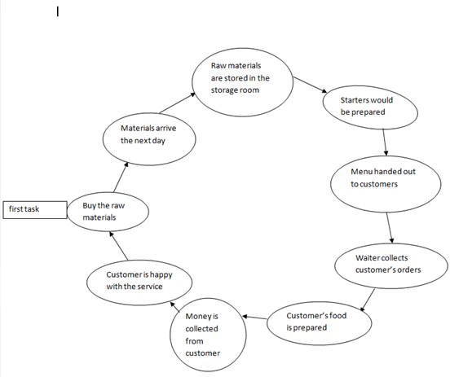

4.2Suppliers
Our suppliers are E and J brands services the reason why we have chosen them as our main suppliers is because out of all the other suppliers they are the only one that offers a high diverse range of quality products which is what we need. Whereas the other suppliers only sell a specific range of products which is not what we are looking for. Also they operate on a national scale so they distribute all over within England. In terms of the payment schedule we have agreed to pay in instalments for their products at the end of every two months for a couple of months with our business credit account. Then after a while we would set up a direct debit with them, though they are not local to us our goods will be delivered to us no less than two days.

4.3Management Team
As we are a start-up business for the first couple of months we would be doing most of the work ourselves in order to save on money .However we would be recruiting a chef and a delivery man which will be delivering the orders to the customers. Also the two of us would be running the day to day operations making sure everything is in order. Describe the management team. Use job descriptions and selection criteria for each member of the management team. Describe how you will measure their performance.
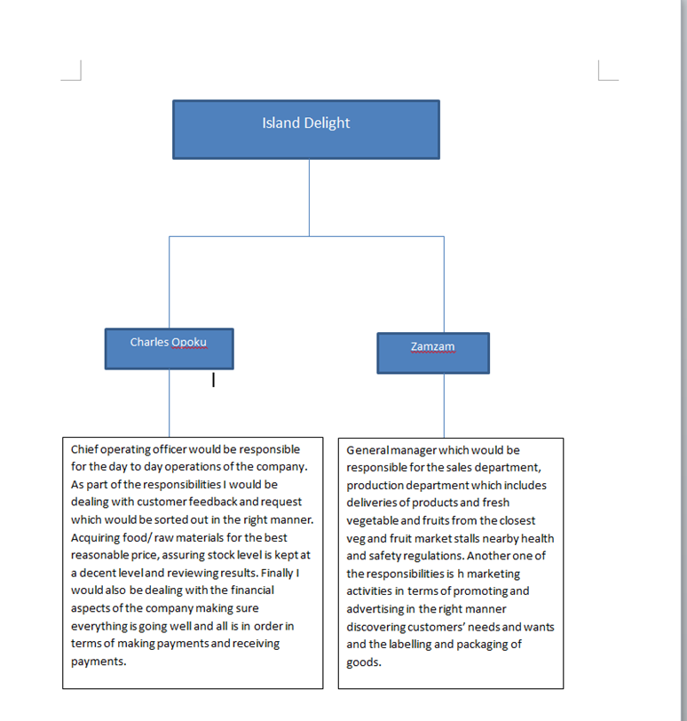

4.4Staff
In terms of staff recruitment we would be recruiting externally not internally though it would be costly due to advertising and training of future employees. First of all the positions that are vacant at the moment is the kitchen chef and delivery man. It is very important for our business that the job description and person specification outlines the key skills and responsibilities of these roles. While also respecting and abiding by the legislations like Race relations, Disability and Sex discrimination act as well as other acts that make future employees not feel discriminated. Describe how you will recruit staff. Motivation is an important factor in how our employees perform so we would be taking it seriously as that will have an impact on how our chef and delivery man performs. The way in which their performance would be checked is by using different quality methods such as the kitchen area being clean nice and tidy, customers comments on the food service and the delivery man’s service towards our customers. Provide a simple application form for staff. Describe how you will measure their performance.

4.5Key Personnel
In terms of key personnel there are a few people that would be able to help us run the business smoothly and ensure the business stays successful.

Mr John Cornway – Huntley legal solicitors which would be in charge of the legal framework which would be needed in months three, seven and ten. As well as that a one off payment would be made every time he is needed. The reason why we have chosen them is because they specialise in helping small companies deal with their legal framework.

Ms Sara Rosemond – Braant accounting which would be overseeing our financial accounts and her services would be needed in months three, seven and ten. As well as that a one off payment would be made every time she is needed. The reason why we chose them above the others is because based on the reviews from other businesses around the area they were chosen as the best ones as they provide valid and accurate financial information.

Mr Wayne Johnson- Control system installation would be responsible for the maintenance of the electricity and fixture and fittings. As well as that a one off payment would be made every time he is needed which would be once every three months. The reason why they were chosen was because they have the vastest experience than the other companies with high quality service to their customers for ten years running.

4.6 Record Keeping
It is very important that we as a business keep the every day to day record of our financial transactions. This is because if his is not accurately kept up to date and in a safe place the consequences that could occur would have a big negative effect on how the business runs. As well as that the records that we would be keeping documented would be income received from the business like receipts books and invoices, email records and invoices for purchases of items and account statement of expenses that the business incur. Due to the fact we may have trouble keeping an accurate up to date file of all these important records we have hired an accountant which is reliable o sort it out for us.

Finally there are a few advantages of record keeping
- One of the advantages is we would be able to provide Inland Revenue Division the information to file a tax return as well as to give the relevant information if our business is being audited.
- The second advantage is that this would help us in terms of providing the right financial information for potential investors and creditors. This would also help s make informed decisions about the business.
- The last advantage would be if financial control is being maintained properly then this would maximise profits if revenue and expenses are balanced. However if the businesses resources are not being managed efficiently then the proper record keeping will help us determine that and we will look to resolve that issue quickly.

5. Risk Assessment
In this section we will be talking about the risks that might happen if we enter the industry and how we will avoid such risks. We also have to follow the risk assessment procedures in order to protect our employees from and dangers at work by training them.

5.1Industry Risk Assessment
There lots of risks that are likely to happen in the kitchen such as falls, fire, electric shocks and gas and that cause a huge damage both to the staff and the premises, therefore we have to be careful and always curry out a risk assessment in order to work in a safe place.

Dangers at re serious s issue as it can put the company in trouble for example if a n employee falls and the matter is not looked into or taken serious we might end up being sued, therefore our role is to train staff about risk assessment in order to avoid such problems.

RISK ASSESSMENT
What are the hazards | Who might be harmed and how | What are you already doing | What further action is necessary | Action by who? | Action by when? | Result
Slips and Trips | Chef and fellow staff members may slip from water on the surface | - Kitchen surface floor is clean and dry  - Equipment kept in safe place exposed cables leading to electrocuted report to manager | - Decision on applying sign to make workers and customers aware.  - Repair damaged floor tiles in the kitchen area  - Remind chef and fellow workers to wear suitable footwear to ensure their safety | CO, GM and ZM | 20/9/15 | 10/9/15
Manual Handling | Staff of chef might endure injuries such as bruising and strains from holding heavy . | - Ingredients bought in package sizes are light enough for easy handling  - Staff are trained on how to lift heavy objects safely  - Handling equipment’s would be provided to staff for heavy objects | - We would make sure that the team dealing with collecting the goods are working well together to make sure no accidents occur  - Lifting machines would be provided to the team to make sure its easier for them to hold without putting strain on their selves | CO, GM and ZM | 27/9/15 | 15/9/15
Knives | - Kitchen staff and chef may cut themselves from chopping up onions and other ingredients etc | - Staff would be well trained on how to handle knives when in use so they do not harm themselves  - Knives will be kept securely in draws when they are not being used | - First aid would be provided in case of accidents occurring by the use of knives  - Chef and staff would be notified that they should not use the knives to open up food packaging | CO, GM and ZM | 25/9/15 | 8/9/15
Contact with hot water and oil | - The chef and his/her staff would be affected if they were to keep their hands running with hot water which can cause burning to the skin. | - To ensure staff safety they will be trained on how to use a dishwasher instead of them hand washing the plates  - All containers would be clear and easily visible to make staff aware of certain risks if in contact with skin or eyes | - Staff would be constantly reminded to make sure they dry their hands after washing.  - Staff would be reminded to check their self if their skin is feeling irritated, dry or itchy | CO, GM and ZM
Food handling | Chef and staff can be harmed by them washing their hands on a frequent basis which might cause damage to their skin after a while | - Staff might use gloves, cutlery and scoop s to handle food instead of using their hands | - Staff would be reminded to check their self if their skin is feeling irritated, dry or itchy  - Specific type of creams like non taint, nut oil would be provided to staff so they regularly apply it to themselves to replace the moisture  - ‘stripped’ by frequent washing. | CO, GM and ZM
Fire | Chef, staff and customers could suffer serious injuries from burns/smoke  Inhalation. | - A fire risk assessment is done at www.communities.gov.uk/fire and necessary action would be taken.  - Staff may not be concentration on what they are cooking and could leave it on the stove which would cause a fire | - Fire extinguishers are provided in the kitchen area for staff to sue in case of fire.  - The extinguishers are also held in the dining area. | CO, GM and ZM | 23/915 | 18/9/10
Electrical | staff could suffer from serious injuries because if electric shocks | - Access to the fuse box should always be clear  - The system in the kitchen should always be inspected and tested by an electrician for at least every after five years to make sure everything is still safe.  - All staff should be aware of where to switch off the fuse in case of an emergency. | - Manager has to inspect all the plugs and cables regularly.  - Manager should also bring in n electrician to inspect and test the equipment. | CO, GM and ZM
Machinery | Stuff working in the kitchen could face serious injuries from dangerous or moving machines | - All staff should be trained on how to use machine while cleaning and assembling them.  - They should be a daily check up on machines before use.  - Operation instructions should always be clear and easy to locate. | - The manager should always remind staff to switch off the machines before cleaning. | CO, GM and ZM | 29/9/10 | 17/9/15
Gas | Staff working in the kitchen could face serious injuries from the release of gas | - They should be a daily check up on gas appliances  - Inspection and testing should be carried out every after 12 months | - Contact Gas Safe registered engineer to fit suitable flame failure device on cooker. | CO, GM and ZM | 16/9/15 | 3/9/15

5.2Business Structure Assessment
We have some weaknesses and threats that we might face such as forgetting to do a risk
assessment procedure which might cause harm to the staff, therefore we have to make sure we
train our staff about it; this will prevent us from dangers at our kitchen.

We plan to advertise the business through leaflets, social Medias (Facebook, Twitter, and Instagram) which will help us let people know about our business, word of mouth is another method we planning to use mostly through friends and family.

Being a small business we might lack some skills which will result to failure for then business so we plan to hire people who more skilled than us and also take trainings on certain we might not be good at in order to be able to handle situations mostly when it comes to working in safe area.

Technological development has advantages and disadvantages which has benefited and destroyed businesses for example ordering a meal online was not as easy as it is nowadays as people did not know how to use computers and some did not even own one, but things have been simplified in a way that businesses have apps that can be used on mobile phones, tablets and laptops or computers which makes life easy for everyone.

Disvantage to this is that people re sometimes misled about the information given out by businesses and in order for us to avoid such problems we will be more careful of what we advertise and provide the exact products. This can be led to our risk assessment procedure through installing the right equipment.

5.3Risk Mitigation
Risk mitigation is the process of developing options and actions to enhance opportunities and reduce threats to project objectives This will help us to reduce an extend exposure of risk that might happen at work. During this process we have to identify the risks, analyse them then find ways to stop them from happening.

Slips and Trips: Decision on applying sign to make workers and customers aware. Repair damaged floor tiles in the kitchen area, remind chef and fellow workers to wear suitable footwear to ensure their safety.

Electrical: Manager has to inspect all the plugs and cables regularly. Manager should also bring in an electrician to inspect and test the equipment before use to make sure everything safe.

Fire: Fire extinguishers are provided in the kitchen area for staff to sue in case of fire. The extinguishers are also held in the dining area where there visible for all the staff to have access too.

6. Financial Plan

11. Short or Long Term Finance
Business should consider short and long term finance cost, due to which profit margin of firm has been increased. In this business plan, management will consider long term finance that is debt finance and equity finance. Debt finance will be taken from bank by issuing long term bond while equity finance will be increase through additional partners in an operating activity of restaurant (p. 780).

12. Rationale behind Chosen Source of Finance
Island delight will take long term finance in order to increase profit margin of firm. In short term finance, management have to pay back finance cost and capital after one year, which will be impossible for the management (Brealey, 2012, pp. 780-785).

13. Cost
Startup Costs
Island delight will be partnership firm where capital used for initial investments will base upon the debt and equity of the capital invest in the business. Initially, owners will invest their personal equity amounts and the capital required will be taken from the bank in terms of loans. The start up cost of new business will be 1 million, which will be taken from equity finance and debt finance. Equity finance will constitute 49% of finance amount while debt finance will constitute 51% of finance amount.

Fixed and Variable Cost
Fixed cost includes rent of restaurant and other expenditure while variable cost includes direct material; direct labor and factory overhead. In this way, Island delight will incur £75,000 of variable cost while £25,000 of fixed cost in an operating activities of restaurant.

Financial Forecasting and Break Even Analysis

14. Budget
Sales Budget
According to sales budget of Island delight restaurant, management will be able to sell 25000 units in first year of business. However, the unit price of product will be £20, due to which management will enjoy net sales amounted to £500,000. This sales amount will increase to £1,600,000 after end of fifth year.
Afro Caribbean restaurant
Sales Projections
2015 2016 2017 2018 2019

Unit Volume 25,000 35,000 40,000 45,000 50,000
Unit Price £20.00 £25.00 £27.00 £30.00 £32.00
Net Sales £500,000 £875,000 £1,080,000 £1,350,000 £1,600,000

Cost and Purchase Projection
Management will bear variable and fixed cost amounted to £100,000 at the end of first year, which will be increased to £180,000 at the end of fifth year. Other cost of operation will be wages expense, rent expense, interest expense, depreciation expense, insurance expense and so.
Afro Caribbean restaurant
Cost or Purchase Projections
2015 2016 2017 2018 2019
Unit Volume £25,000 £35,000 £40,000 £45,000 £50,000
variable cost £75,000 £105,000 £120,000 £135,000 £150,000
Fixed Cost £25,000 £27,000 £24,000 £22,000 £30,000
Cost of Goods Sold £100,000 £132,000 £144,000 £157,000 £180,000

15. Financial Forecast
Budgeted Income Statement
Budgeted net income of Island delight restaurant will be £285,088 at the end of first year of operation, which will be increased to £1,050,088 at the end of fifth year.
Afro Caribbean restaurant
Income Statement
2015 2016 2017 2018 2019

Net Sales £500,000 £875,000 £1,080,000 £1,350,000 £1,600,000
(Cost of Goods Sold) £100,000 £132,000 £144,000 £157,000 £180,000
GROSS PROFIT £400,000 £743,000 £936,000 £1,193,000 £1,420,000
Less: Operating Expense
Wages Expense £6,100 £6,100 £6,100 £6,100 £6,100
Insurance Expense £10,000 £10,000 £10,000 £10,000 £10,000
Rent Expense £3,000 £3,000 £3,000 £3,000 £3,000
Depreciation Expense £167 £167 £167 £167 £167
Depreciation Expense £167 £167 £167 £167 £167
Total Operating Expense £19,433 £19,433 £19,433 £19,433 £19,433
EBIT £380,567 £723,567 £916,567 £1,173,567 £1,400,567
Less: Interest Expense £450 £450 £450 £450 £450
EBT £380,117 £723,117 £916,117 £1,173,117 £1,400,117
Less: Tax Expense £95,029 £180,779 £229,029 £293,279 £350,029
Net Income £285,088 £542,338 £687,088 £879,838 £1,050,088

Budgeted Balance Sheet
Budgeted total assets of Island delight restaurant will be £946,000 at the end of first year of operation, which will be increased to £2,046,000 at the end of fifth year. These asset resources will be increase due to long term finances that are debt finance and equity finance.
Afro Caribbean restaurant
Balance Sheet
2015 2016 2017 2018 2019
ASSETS
Current Assets
Cash £500,000 £875,000 £1,080,000 £1,350,000 £1,600,000
Inventory - - - - -
Other Current Assets £50,000 £50,000 £50,000 £50,000 £50,000
Total Current Assets £550,000 £925,000 £1,130,000 £1,400,000 £1,650,000

Fixed Assets
Coffee Machine & other Equipment £200,000 £200,000 £200,000 £200,000 £200,000
(Less Accumulated Depreciation) £2,000 £2,000 £2,000 £2,000 £2,000
Coffee Machine & other Equipment £198,000 £198,000 £198,000 £198,000 £198,000
delivery van £200,000 £200,000 £200,000 £200,000 £200,000
(Less Accumulated Depreciation) £2,000 £2,000 £2,000 £2,000 £2,000
Delivery van £198,000 £198,000 £198,000 £198,000 £198,000
Total Fixed Assets £396,000 £396,000 £396,000 £396,000 £396,000

TOTAL ASSETS £946,000 £1,321,000 £1,526,000 £1,796,000 £2,046,000

LIABILITIES
Current Liabilities
Short-Term Notes Payable £17,500 £18,000 £17,500 £18,500 £19,000
Total Current Liabilities

Long-Term Liabilities
Long-Term Notes Payable £500,000 £589,413 £537,663 £661,913 £718,663

NET WORTH
Paid-In Capital £428,500 £428,500 £428,500 £428,500 £428,500
Retained Earnings £285,088 £542,338 £687,088 £879,838
Total Net Worth £713,588 £970,838 £1,115,588 £1,308,338
TOTAL LIABILITIES AND NET WORTH £946,000 £1,321,000 £1,526,000 £1,796,000 £2,046,000

Break Even
Break even is calculated by using three different financial components that are fixed cost, variable cost per unit and selling price per unit. The break even unit of Afro Caribbean restaurant will be £1247 in the first year of operation.
Afro Caribbean restaurant
Break Even
2015 2016 2017 2018 2019
Fixed Cost £25,000 £27,000 £24,000 £22,000 £30,000
Variable cost per unit £3 £3 £3 £3 £3
selling price per unit £20 £25 £27 £30 £32
Break Even £1,247 £1,077 £886 £730 £935

Cash Flow Forecast
Island delight restaurant will bear cash outflow of £419,433 and enjoy cash receipt of £928,500. In this way, management will enjoy cash amount of £509,067 from the first year operating activities.

Afro Caribbean restaurant
Cash Flow Statement
2015 2016 2017 2018 2019

CASH RECEIPTS
Income from Sales
Share Capital £428,500 £428,500 £428,500 £428,500 £428,500
Cash Sales £500,000 £875,000 £1,080,000 £1,350,000 £1,600,000
TOTAL CASH RECEIPTS £928,500 £1,303,500 £1,508,500 £1,778,500 £2,028,500

CASH DISBURSEMENTS
Inventory - - - - -
Operating Expenses £19,433 £19,433 £19,433 £19,433 £19,433
Capital Purchases £400,000 £400,000 £400,000 £400,000 £400,000
TOTAL CASH DISBURSEMENTS £419,433 £419,433 £419,433 £419,433 £419,433

NET CASH FLOW £509,067 £884,067 £1,089,067 £1,359,067 £1,609,067

7. References

Brealey, R. A. (2012). Principles of corporate finance. Tata McGraw-Hill Education. 780-785. Data Retrieved From: http://books.google.com/books?hl=en&lr=&id=XMGjAgAAQBAJ&oi=fnd&pg=PR1&dq=Short+or+Long+Term+Finance+in+business+plan&ots=rjTRis8TxN&sig=pIbg169sGoAO0T-uP1UPUWDUMHk#v=onepage&q&f=false

Celsi, M. W., Money, A. H., Samouel, P., & Page, M. J. (2011). Essentials of business research methods. ME Sharpe. . 50-200. Data Retrieved From: http://books.google.com/books?hl=en&lr=&id=MpAAnXiBTW4C&oi=fnd&pg=PR3&dq=Primary+Market+Research+in+research+analysis+of+business+plan&ots=Bgh5fKUT68&sig=vB3PPtXzIAdUKCwVZwcdaPmYOs0#v=onepage&q&f=false

Finch, B. (2013). How to write a business plan (Vol. 35). Kogan Page Publishers. 1-350. Data Retrieved From: http://books.google.com/books?hl=en&lr=&id=jFFCGKTjQ4MC&oi=fnd&pg=PR5&dq=Location+Of+Restaurant+in+business+plan&ots=5jfRBSBYEe&sig=P_lMcfOP1XTS-CrhCG4L8HwaXbY#v=onepage&q=Location%20Of%20Restaurant%20in%20business%20plan&f=false

Gatewood, R., Feild, H., & Barrick, M. (2010). Human resource selection. Cengage Learning. 65-211. Data Retrieved From: http://books.google.com/books?hl=en&lr=&id=JdE8AAAAQBAJ&oi=fnd&pg=PR7&dq=Human+Resource+in+business+plan&ots=7Be683tpKv&sig=WiZXzWBziT3la--uXlsSZpNx44g#v=onepage&q&f=false

Hyun, S. S. (2010). Predictors of relationship quality and loyalty in the chain restaurant industry. Cornell Hospitality Quarterly, 51(2), 251-267. Data Retrieved From: http://cqx.sagepub.com/content/51/2/251.short

Saunders, M. N., Saunders, M., Lewis, P., & Thornhill, A. (2011). Research methods for business students, 5/e. Pearson Education India. 1- 300. Data Retrieved From: http://books.google.com/books?hl=en&lr=&id=ermlN0ppilMC&oi=fnd&pg=PR1&dq=Range+Of+Secondary+Market+Research&ots=Vu4b9dktQ-&sig=2t-9z1AgqIZSPuyUjCNWtHapDOQ

Teece, D. J. (2010). Business models, business strategy and innovation. Long range planning, 43(2), 172-194. Data Retrieved From: http://books.google.com/books?hl=en&lr=&id=YnCcAQAAQBAJ&oi=fnd&pg=PP2&dq=Legal+Structure+of+organization+in+business+plan&ots=IikiXwjy4x&sig=F8THIFbA1x9y6gZuoVvhcwrp0Ww#v=onepage&q&f=false

http://www.allinlondon.co.uk/regions/tottenham/restaurants.php

https://www.keynote.co.uk/market-intelligence/view/product/11493/restaurants/chapter/1/executive_summary?highlight=restaurant%20industry

http://www.startupbizhub.com/what-type-of-business-is-a-restaurant.htm

Lorri mealey. (2015). Kitchen Equipment Checklist. Available: http://restaurants.about.com/od/stockingarestaurant/a/KitchenChecklis.htm.
http://restaurants.about.com/od/stockingarestaurant/a/KitchenChecklis.htm

http://startups.co.uk/10-ways-to-fund-your-business-without-a-bank-loan/

Mitre Corporation. (2015). Risk Mitigation Planning, Implementation, and Progress Monitoring. Available
.http://www.mitre.org/publications/systems-engineering-guide/acquisition-systems-engineering/risk-management/risk-mitigation-planning-implementation-and-progress-monitoring

W2beyond. (2015). Inland Revenue division. Available: http://ird.gov.dm/index.php?option=com_content&view=article&id=59:the-importance-of-record-keeping.
http://ird.gov.dm/index.php?option=com_content&view=article&id=59:the-importance-of-record-keeping

http://www.startupbizhub.com/what-type-of-business-is-a-restaurant.htm

