Business start-up – workbook
Student Name:
University:

1. Your business idea
Choose the idea you want to work on throughout the rest of the modules. Briefly describe the idea you want to work on:

- Why is it safe to say that you’re working on a startup?

- What are Steve Blank’s 3 key principles for startup business models?

- Now explain why your idea is in tune with these 3 key principles.

- We’ve seen 11 of the most common risks that could affect new ideas. It’s important to think ahead and understand that our startup could involve some of these risks. Think about which 3 risks are most likely to affect your idea, explain why and suggest some initial alternatives for avoiding them.

2. Living on the edge: Why startups fail
- Plan ahead and choose from among the 20 reasons we’ve seen 4 that could make your startup fail.
- Think of a possible solution for each one! :D

Reason 1  Solution 1 | Reason 2  Solution 2
Reason 3  Solution 3 | Reason 4  Solution 4

3. Business Model Canvas
In this module you should only set the guidelines for your Business Model Canvas, where as in the next and the last module you will be analysing it in detail. If you don’t have an idea of your own, choose any business and analyse it.

Customer Segments
For whom are you creating value? Who are your most important customers?

Value Propositions
What value do you deliver to the customer? Which one of your customer’s problems are you helping to solve? What bundles of products and services are you offering to each Customer Segment? Which customer needs are you satisfying?

Channels
Through which Channels do your Customer Segments want to be reached? How are you reaching them now? How are your Channels integrated? Which ones work best? Which ones are most cost-efficient? How are you integrating them with customer routines?

Customer Relationships
What type of relationship does each of your Customer Segments expect you to establish and maintain with them? Which ones have you established? How are they integrated with the rest of your business model? How costly are they?

Revenue Streams
For what value are your customers really willing to pay? For what do they currently pay? How are they currently paying? How would they prefer to pay? How much does each Revenue Stream contribute to overall revenues?

Key Resources
What Key Resources do your Value Propositions require? Your Distribution Channels? Customer Relationships? Revenue Streams?

Key Activities
What Key Activities do your Value Propositions require? Your Distribution Channels? Customer Relationships? Revenue streams?

Key Partners
Who are your Key Partners? Who are your key suppliers? Which Key Resources are you acquiring from partners? Which Key Activities do partners perform?

Cost structure
What are the most important costs inherent in your business model? Which Key Resources are most expensive? Which Key Activities are most expensive?

4. Porter's 5 forces
Use the PORTER diagram to analyse the competitive situation in the industry/sector where you want to launch your business idea. Reflect on each of them and analyse how they could affect your business model.
The threat of new entrants

The bargaining power of suppliers

Rivalry between competitors

The threat of substitute products entering the market

The bargaining power of customers

5. Lean Model Canvas
In this module you should only set the guidelines for your Lean Model Canvas, where as in the next module you will be analysing it more in detail. If you don’t have an idea of your own, choose any business and analyse it.

PROBLEM: Identify the 3 main problems for your customer segment (related with your activity of course!) and find out how they resolve them, i.e. alternatives to your product.

CUSTOMER SEGMENTS: Identify and get to know the customer segments you’re going to work with and, most importantly, go to great lengths to find out who your early adopters or visionaries could be.

UNIQUE VALUE PROPOSITION: Write down a single, clear, compelling sentence (a mini-pitch) about what makes you special and how you’re going to help customers solve a problem.

SOLUTION: Once you’ve identified and prioritised the problems your customers face, decide on the top 3 features of your product/service.

CHANNELS: Now it’s time to work on how we’re going to get our solution to reach our desired customer segment: with a sales team? on the internet?

REVENUE STREAMS: Reflect on how we’re going to make money, everything from different revenue streams to profit margin, customer value, retention model, etc.

COST STRUCTURE: Write down everything that costs us money and the approximate monthly expenses.

KEY METRICS: Create a reduced set of actionable indicators that will help us make decisions.

UNFAIR ADVANTAGE: Think about what makes you special, sets you apart, why your customers keep coming back for more.

Here are some questions about the work tool: Lean Model Canvas.
- In the Customer Segments block, the template asks you to name your target customers and users, but what’s the difference between a customer and a user? Tell us at least 3 differences.
- What was the most complicated part about working with the Lean Canvas?
- Can you tell us why?
- You normally put features in the Solutions block of the Lean Canvas. However, we have to know how to turn these features into benefits, i.e. what they really bring to our customers/users. Choose 3 features and for each one find 3 associated benefits.

6. Process design
List several processes relating to your business idea.
Since we will be working with a finished version of PERT chart all you have to do is to create a list of processes, which we will call Legend, and assign them letter according to their order.
If you don’t have an idea, try using one of the following: Planning a trip to a faraway coastal city; Selling hamburgers; Designing a logotype; Playing music at a wedding.
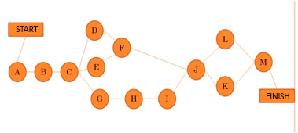
7. Elevator pitch
Let's practice preparing and giving a great speech.
Choose listeners, place and situation, and objectives, and start creating a draft script. Then select and create scenes, don’t forget your conclusion, and order them so that the sequence ends on a high note ;)
Try different combinations and create speeches for:
- 1 minute
- 3 minutes
- 5 minutes
Record yourself, share it, ask for feedback, improve it and keep practising, practising, practising.

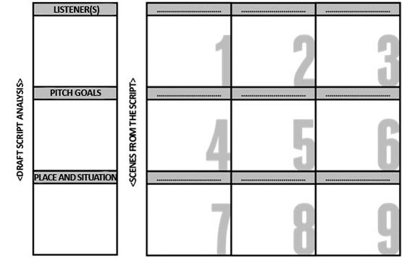
> Elevator Pitch Canvas

8. Partnership Agreement
In this exercise you should try and find solutions to following conflicting situations:
- What happens if a partner pulls out of the project?
- What happens if a partner starts a project that is similar to the startup?
- If a new partner joins, how will the participation percentages be distributed?
- What happens if a partner doesn’t honour their time commitment to the project?
- What happens if a partner doesn’t fulfil the objectives set or perform as expected?
- What happens if there are disagreements over decisions?
- What happens if a veto situation arises?

